Notes on “The Golden Bridge” and Narration
(prequel to “Crossing Bridges”)

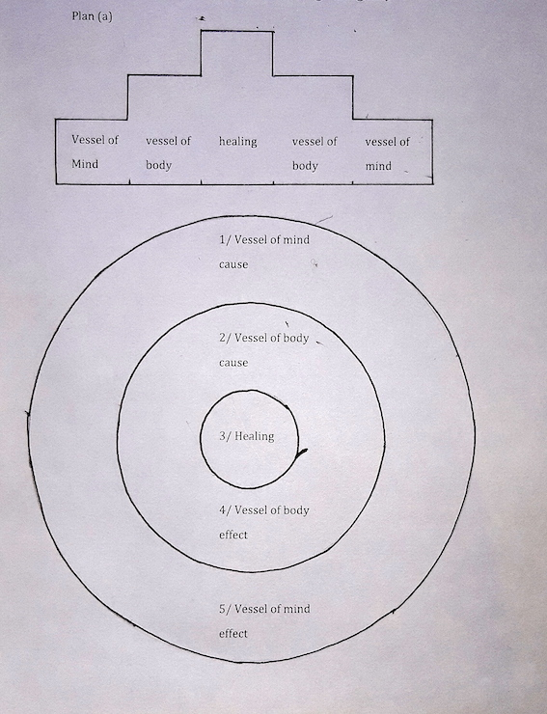
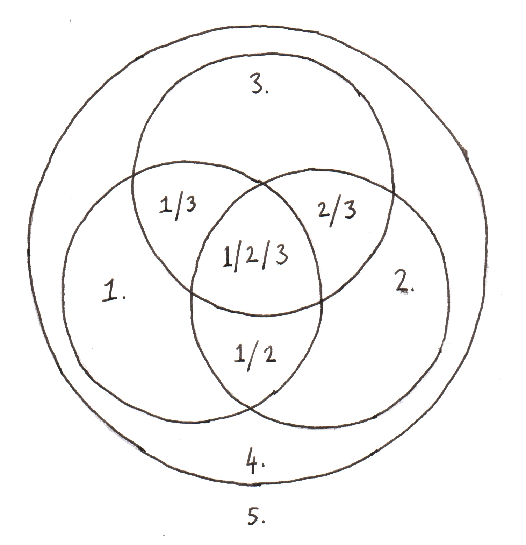

Where…
1. Compassion (represented as water)
2. Ganges River
3. Dr Dass
4. whole bubble = healing
5. Outside of bubble – limitless essential being
So, in this case there are 8 aspects to limited space and 1 that lies beyond, the limitless possiblility of essential spacious being, absolute limitless potential of space.
= 9
So, corresponding to the sequence of 9 sections of visuals, it goes like this:

Run of Bridges – bottom to top
1/ D = 3 on plan b above – DD general, mix with Gaumukh – yellow, earth, Vessel of mind 1 – CAUSE on plan a above
2. Gaumukh = 2 on plan b above – Gaumukh, River to Gangotri
3. D = 3/1 on plan b above – DD & compassion (as water visuals) – red, fire, vessel of body 2 – CAUSE on plan a above
4. Gangotri = 2/1 on plan b above – Gangotri/compassion
5. D = 5. On plan b above – limitless potential – blue, space, Healing 3 on plan a above
6. Devprayag = 3/2 on plan b above – DD and Ranges river
7. D = 4. On plan b above – healing - vessel of body 4 – EFFECT on plan a above
8. Rishikesh = 1/2/3 on plan b above – DD, Ganges River, compassion – mix visuals – green, wind,
9. D = 1 on plan b above – compassion (as water visuals) mixed – white, water, Vessel of mind 5 – EFFECT on plan a above
Run of Bridges – top to bottom (end on same visual as start)

Corresponding to plan a, there are also a number of connections with plan b – see visual layout below
Run of Bridges – lead in and lead out = Shiva statue at Haridwar looking up to the mountains
- Same visuals of initial sequence in lead out, yet reversed.
- Producing mirror-like effect

5 sections of DD
1 – 1/ Vessel of mind CAUSE – mental toxins in mind continuum
- yellow, earth
- – KNOWING – he had the idea to help others through healing and did it by knowing the truth of its potential to come into being
- trust.
3 – 2/ Vessel of body CAUSE – diseases in the body
- red, fire
- DOING – by having compassion towards those sick people, planting cause for healing
- CAUSE AND EFFECT
5 - 5/ Healing – blue, space
- MEDITATION – nature of real healing
- IMPERMANENCE
7 – 4/ Vessel of body EFFECT – healing in body
– green, wind,
- HEALING energy as a result of compassion
- NATURE OF SAMSARA
9 – 5/ Vessel of mind EFFECT – healing in mind
- water, white
- COMPASSION – compassion as a result of compassion
- PRECIOUS HUMAN LIFE

4 sections of Ganges
2 – 1/ Gaumukh, down to Gangotri, dissolve from Gangotri bridge
4 – 2/ Gangotri, activities in Gangotri, dance in Deurali, dissolve from dance arm
6 – 3/ Devprayag, way to Rishikesh, dissolve from water of river
8 – 4/ Rishikesh, activities, yoga, kati bridge yoga position, dissolve from Rishikesh Bridge

As visuals build up, there are reflections of previous sections in later sections, emerging from people’s faces as they remember other parts of Ganga
2/ Gaumukh
4/ Gangotri - show some of previous Gaumukh (flash back)
6/ Devprayag – show some of previous up to Devprayag (flash back)
8/ Rishikesh - show some of previous up to Rishikesh (flash back)

These sections of Ganges River and activities should be shown from the point of view of being inside channels and energies that arise in outer realm… We should look at the ‘disease’ we see in this realm, health and happiness, birth, sickness, old age, death etc…
No fancy fancy, just straight along the road from place to place, what happens and impressions and parallel the river with main channel.

Healing life living
Healing
Disease death dying

Dissolving visuals
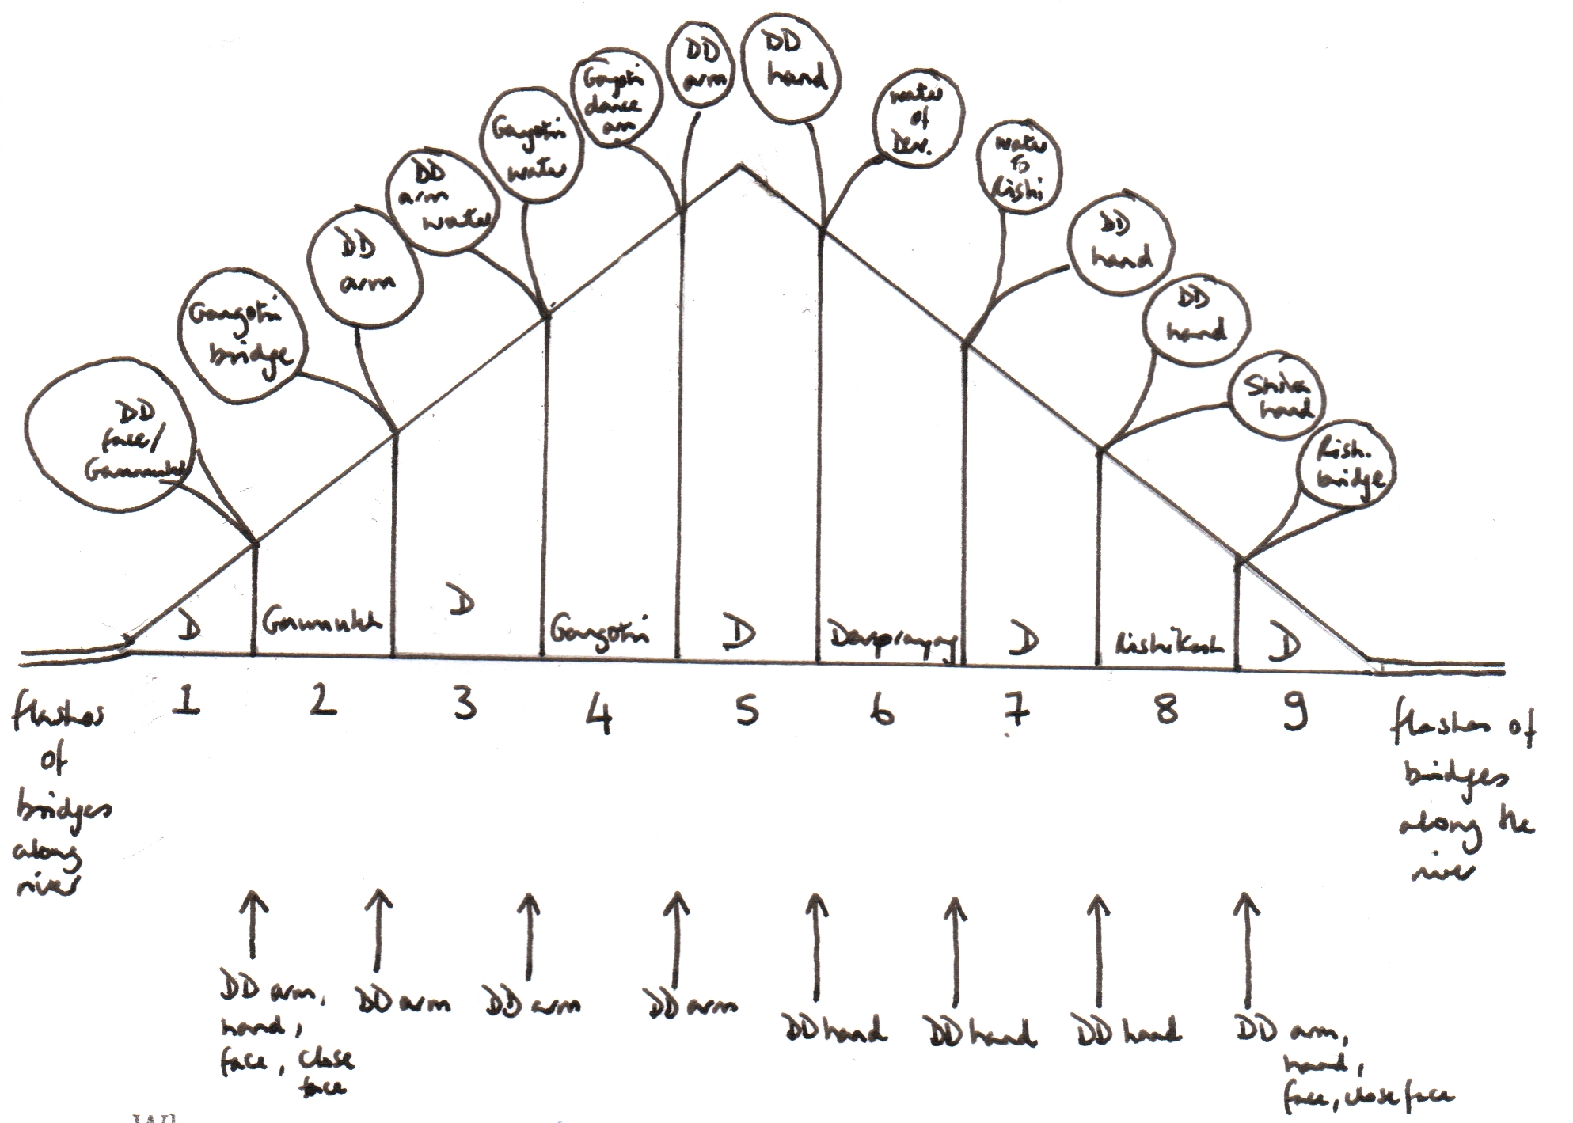
Where… Run of bridges, dissolve from bridge to…
1/ DD – DD general, then in end, DD arm, hand and face and close face mixed with few Gaumukh visuals – 1 min – dissolve from DD close face to…
2/ Gaumukh sun – Gaumukh and road/river to Gangotri - 3 min – dissolve from Gangotri bridge to…
3/ DD arm – dissolve from arm to DD arm to…
4/ Gangotri water, activities in Gangotri, Deurali dance start, dissolve from dance arm to…
5/ DD arm, dissolve from hand in water to…
6/ dance arm - end of dance, Devprayag, water to Rishikesh – dissolve from hand in water to…
7/ DD, hand on head of patient – dissolve from hand on head of patient to…
8/ Rishikesh, Shiva hand, dissolve from Rishikesh bridge to…
9/ DD arm, mix visuals towards end of sequence of DD face, hand and arm mixed with flowing water
SECTIONS 1-9 (Topics for Narration/Visuals)
Where:
D 1/ DD V. OF MIND – CAUSE KNOWING
G 2/ Ganges & Compassion
D 3/ DD & Compassion V. OF BODY – CAUSE DOING
G 4/ Ganges
D 5/ limitless potential DISEASE – HEALING – HEALTH MEDITATION
G 6/ Ganges
D 7/ healing V. OF BODY – EFFECT HEALING
G 8/ Ganges
D 9/ compassion V. OF MIND – EFFECT COMPASSION

Run of bridges - The Healing process
1– 1/ Vessel of mind CAUSE – mental toxins in mind continuum , theme – DD - KNOWING
2 – 1/ Gaumukh, down to Gangotri, dissolve from Gangotri bridge, theme – Ganges & compassion
3 – 2/ Vessel of body CAUSE – disease in the body, theme DD & compassion - DOING
4 – 2/ Gangotri, activities in Gangotri, dance in Deurali, dissolve from dance arm, theme – Ganges
5 - 5/ Disease/Healing/health – blue, space, theme – limitless potential - MEDITATION
6 – 3/ Way to Rishikesh, dissolve from water of river, theme – Ganges & DD
7 – 4/ Vessel of body EFFECT – healing in body, theme – healing - HEALING
8 – 4/ Rishikesh, activities, yoga, kati bridge yoga position, dissolve from Rishikesh Bridge, theme – Ganges, DD & compassion
9 – 5/ Vessel of mind EFFECT – healing in mind, theme – compassion – COMPASSION
Run of bridges - The Healing process
Run of bridges - The Healing process
Mental garbage in the vessel of mind, leading to disease in one’s precious vessel of body.
By putting in rubbish, pollution occurs. One’s outer environment is thus affected.
Healing is required from the very source.

Narration

1/ Dr Dass visuals 1
1– 1/ Vessel of mind CAUSE – mental toxins in mind continuum , theme - DD

(yellow, earth) - KNOWING

After the discovery of his capacity to heal by touch, Dr Dass came back to his homeland of India after a long period of time in Europe.
Wishing to help others by curing their diseases, by knowing or rather trusting in the truth of its potential to come into actual effect, each day he treats as many patients as possible
Those seeking to have their diseases removed and their families stay for long stretches of time here in Mussoorie, at the foothills of the great Himalayan mountain chain in India, as their course of treatment can span months of energy sessions.
Simply wishing to remove the sufferings that their sickness inflicts upon them, they arrive here with both hope and fear.
Fear that the disease may cause ongoing suffering or even overcome them or their loved ones
and hope that they may be restored to perfect health.
Such are the causes for disease to arise laid in the construct of one’s own experience of existence, the fear of it and the hope of it that twist and twirl one’s life force energies into a never-ending dance.
Temporary life within a temporary body,
vessel to carry one through the waves of living,
but a transient
ship on the ocean of existence.
One’s human mind
With capacity to go beyond its ordinary limitations.
where the natural harmful energies that create mental toxins are purified from the mind stream
and no longer reflect into manifest form as disease within the physical body.
One remains naturally healthy.
So is healing required from the very source.

2/ Gaumukh/Gangotri visuals
2 – 1/ Gaumukh, down to Gangotri, dissolve from Gangotri bridge, theme – Ganges & compassion

If the source is pure, what flows from it will be pure…
like the stream of healing energy moving through the earth of the physical body, unblocking the solidity of ice at its source so that a path of existence may flow unhindered to the ocean along the road of least resistance.
Every word spoken and every action conducted is as a result of an initial thought that spurred that movement to take place.
And each movement of the mind affects how we hold our physical posture.
Those movements, those twitching of the energy channels that drive the nerves and sensations we feel and emotions we experience, accumulated in certain places through certain habits, lead to blockage in the flow of energy and therefore disease in the physical body.
By repairing the space of our mental being within which our thoughts arise, the health of the physical body may also be restored,
as well as a natural feeling of compassion towards the outer environment and its inhabitants,
one vast pulsating energy.
Just as Ganga has a natural healing virus in her stream that thrives on certain bacteria that thus multiply, creating her own curative properties, so she maintains her balance.
Thus, one may keep one’s physical body running smoothly, outwardly reflected as a balanced environment from which one may derive its fully operative and limitless potential.
The Earth, like the River offers itself mercilessly.

3 / Dr Dass visuals 2
3 – 2/ Vessel of body CAUSE – diseases in the body, theme DD & compassion
(red, fire) - DOING - CAUSE AND EFFECT

First, one has to accept sickness before seeking healing.
For stemming from essential space, deranged mental patterns emerge as a result of previously created energy patterns that in any certain moment may arise as all the conditions for them to appear are there.
These energy patterns then emerge as disease within their physical bodily aspect, which thus needs to be healed or rather restored to its natural state.
Each person has his/her natural healing power within, but if overloaded with toxins of mind and body that are not being cleared but constantly being re-enforced by habitual way of doing, saying and thinking things, then one’s own inherent ability to heal oneself is overwhelmed and one’s body can no longer cope.
Many diseases stem from very subtle energy derangements and are difficult to detect, especially at a mental level.
Healing on the part of the doctor and on the part of the patient takes place in quantitative measures, the doctor through his compassionate offering of healing and the patient through his faith in the doctor as well as trusting in the nature of his healing.
Through recognising the disease as a derangement of energy in a certain area of the body, the doctor will restore the imbalanced energy to its natural state, kick starting its own curative techniques through which in turn it may generate its own healing.
Having an ongoing compassionate wish to help and serve others selflessly, the energy of healing is present.
Such is the desired effect of healing, the cause of health of body and mind, that they may be restored to their naturally perfect state that inherently knows how to maintain its perfect balance.

4 / Gangotri/Deurali visuals
4 – 2/ Gangotri, activities in Gangotri, dance in Deurali, dissolve from dance arm, theme - Ganges

In her outward display, the River Ganges represents a relative condition.
She must flow down, she must melt from ice to water when the temperature goes above a certain point, she must flow into the ocean where there is no more land.
She is dependent on how others treat her. She cannot shout out loud ‘Do not pollute me with industrial waste!’
When there is a big boulder in the middle of her path, she must course around it and she must run the route that is the easiest for her flow.
She is bound by causes and conditions.
Fast flowing through rocky gorges, like the power of the healing energy zapping into the system and smoother, more gentle flow, like the healing energy settling into a more stable pace as it gathers support from its tributaries along its course, the river runs its course.

5/ Dr Dass visuals 3
5 - 5/ Healing – blue, space, theme – limitless potential
- MEDITATION – nature of real healing
- IMPERMANENCE

Many people around the world are having good ideas and are trying their best to bring them into reality.
How is it or why is it that sometimes it works and sometimes it doesn’t work when mind is in its absolute sense, limitless. It can reach anywhere, have any idea, create anything it wants.
For it is still boundaried by its physical relative causes and conditions.
The ability to bring ideas which are born from the limitless mind into manifest reality or the power to heal through a charge of subtle energy through the physical body that contains the sickness in essential form as deranged energy patterns, is not beyond human capacity, but an inbuilt gift of our natural state as humans.
For energy that is appearing in a deranged way is thus scattered through the focus of healing energy coming from the doctor, who encourages the energy to normalise and thus produce its own healing power.
So just as the bridge cannot stand without two sides holding it, compassion cannot arise without wisdom that knows both its limitations as well as its limitless nature.
Only mind ‘drowned’ in compassion can go beyond its natural limitations.
Arising simultaneously together, compassion and wisdom merge, or recognise their union, supreme ingredient of the art of creation and manifestation,
like the flow of a river that may never stop for an instant on its course, ever-changing position, never standing still, providing, offering, sustaining.
Healing, just as step by step one passes from one side of the bridge of disease to another bridge of health, one passes over just one bridge.
So does the healing lead disease to its goal of health.

6 / Rishikesh visuals
6 – 3/ Way to Rishikesh, dissolve from water of river, theme – Ganges & DD

By sitting and calming one’s mind to a balanced state or by participating in one’s endeavours with full focus and willpower, one’s thought will be clear, one’s speech will be transmittable and one’s actions will be honourable.
In Ganga’s mythologyical story, Brahma tells Ganga that she may never be polluted by man as she herself is pure.
Indeed, in essence, she may never be polluted and by offering herself mercilessly to mankind for whatever purpose he wishes, totally succumbing to the wills and whims of others without complaint, she gives of her naturally appearing resources with such compassion that her purity is maintained no matter what.
Man sees her as a great fulfiller of his wishes, yet he is selfish for his needs without insight into her real nature, what she may really give him.
For without real insight into his own perfect nature of being, she will meekly and compassionately reflect his all and sundry needs until he recognises the truth of her energetic being.
For her essential nature arising as a body of water, is relatively effected by the environment of her earthly passage, just as the jewels she has to offer mankind throughout her natural course are dependent on her general well-being as an energy flow of water upon a body of earth.
For in relative time and space reality, there are limits. We are bound by hours of the day and night, need to sleep, eat, drink, bound by the human condition in which we must be born, grow up, grow old, grow sick and die.
Like being confined within a certain space for a certain period of time, bubbles held together by life-force sealed within their tightly bound encasement of physical body.
Through performing physical yoga, we may keep essential flows of body channel energy running smoothly.
Water is another vital input.
We, as an intelligent species have the mental capacity to understand the value and importance of water to our very existence. Not understanding this simple point, that aspect of ignorance only leads to our own suffering when water can no longer sustain our basic need to merely live, to keep the physical body functioning at its most basic level.
Naturally, water flowing along the earth and from within the earth contains minerals and vitamins that have accumulated along their passage. And water that flows from the pure, clean sky contains the very valuable ability to oxygenise the earth’s surroundings and inhabitants.
Realising the truth of water is therefore like realising the truth of our very existence, drowning ignorance in the waters of compassion.

7 / Dr Dass visuals 4
7 – 4/ Vessel of body EFFECT – healing in body, theme - healing
– green, wind
- HEALING energy as a result of compassion
- NATURE OF SAMSARA

The result of being compassionate is having compassion,
using the precious vessel of human life for other’s needs,
input at the source is pure,
result is pure.
So just as people demand of the river, so do endless streams of sick people come to request Dr Dass to help them.
And so, he offers compassionate healing energy to all who come to him, the Golden Bridge that spans between diseased and healthy,
and whatever people demand, he gives what he can of himself to aid their healing process into action.
According to many traditions of inner yoga, there are many centres of energy located down the main channel of energy that runs from the spine to the crown of the head.
Seven main ones are often identified, each distributing certain essential energies to the various parts of the body they are associated with.
Through analysing the position and cause of the disease, Dr Dass can identify which chakra, or ‘wheel’ of energy that diseased region is associated with.
It is the natural outcome of the subtle energy of mind working together with the solid physical body, perfectly and harmoniously in alignment with each other that holds the whole physical form of the body together.
But it takes more to heal the body than to just heal the body, as it is our energy patterns that are the seeds for the manifesting physical body to appear in the way it does.
Therefore charging the necessary chakra with his healing energy, he restores the imbalance.

8 / Rishikesh/Haridwar visuals
8 – 4/ Rishikesh, activities, yoga, kati bridge yoga position, dissolve from Rishikesh Bridge, theme – Ganges, DD & compassion

In this sense Ganga performs her duty as a wish-fulfilling goddess.
For man uses her for whatever he needs; drinking, bathing, worshipping, industry and travel among many others.
She curves and twists along the path of least resistance to the ocean and along the way, she offers herself to be used for whatever purpose necessary for each individual that comes into contact with her.
She gives no preference to one over another, but offers herself equally to each one as he or she wants of her.
Whatever one asks of her, she reflects, she gives to him. If he takes, she gives. If he worships, she gives blessings; if he bathes, she washes; if he needs energy for electricity, she simply runs the course dictated.
And yet, she does nothing but just run her course of least resistance to the ocean.
‘Shining’ her natural aspect by just ‘being’ her natural aspect, she empowers whoever beholds her, giving space for their inherently natural ‘shining qualities’ to emerge too thus raising their inherent healing qualities to overpower the toxication of the physical body with its mental patterns of input.
For the precious human vessel of body is like a bolt of energy off-streaming from its essential being. Sustaining that voltage for a while in terms of relative time and space within which the bolt appears, so can it recharge its natural attributes to their balanced nature.
Limitless possibilities, limited space within which they may appear.
Limitless space, limited by its ever-changing manifestations of potential.

9 / Dr Dass visuals 5
9 – 5/ Vessel of mind EFFECT – healing in mind, theme - compassion
- water, white
- COMPASSION – compassion as a result of compassion
- PRECIOUS HUMAN LIFE

With a little amount of mindful actions, the natural healing properties of each of our rivers that entwine and merge with one another may be restored so that each one of us may pour forth water beneficially to all who come requesting.
For the stream of the golden river of compassion is like a bridge carrying each individual on his or her path to the ocean of essential being.
A bridge of energy through which the self-healing energy of the patient may be reactivated.
The golden bridge spanning the width and breadth of our existence, making the union way between its two fundamental realities of limited and limitless.
One bridge to unite these two aspects, that automatically become one, once the bridge is there.
Compassion…
the golden bridge…
to unite…
all.

